094101 GOLDEN TOP PLUS ALU
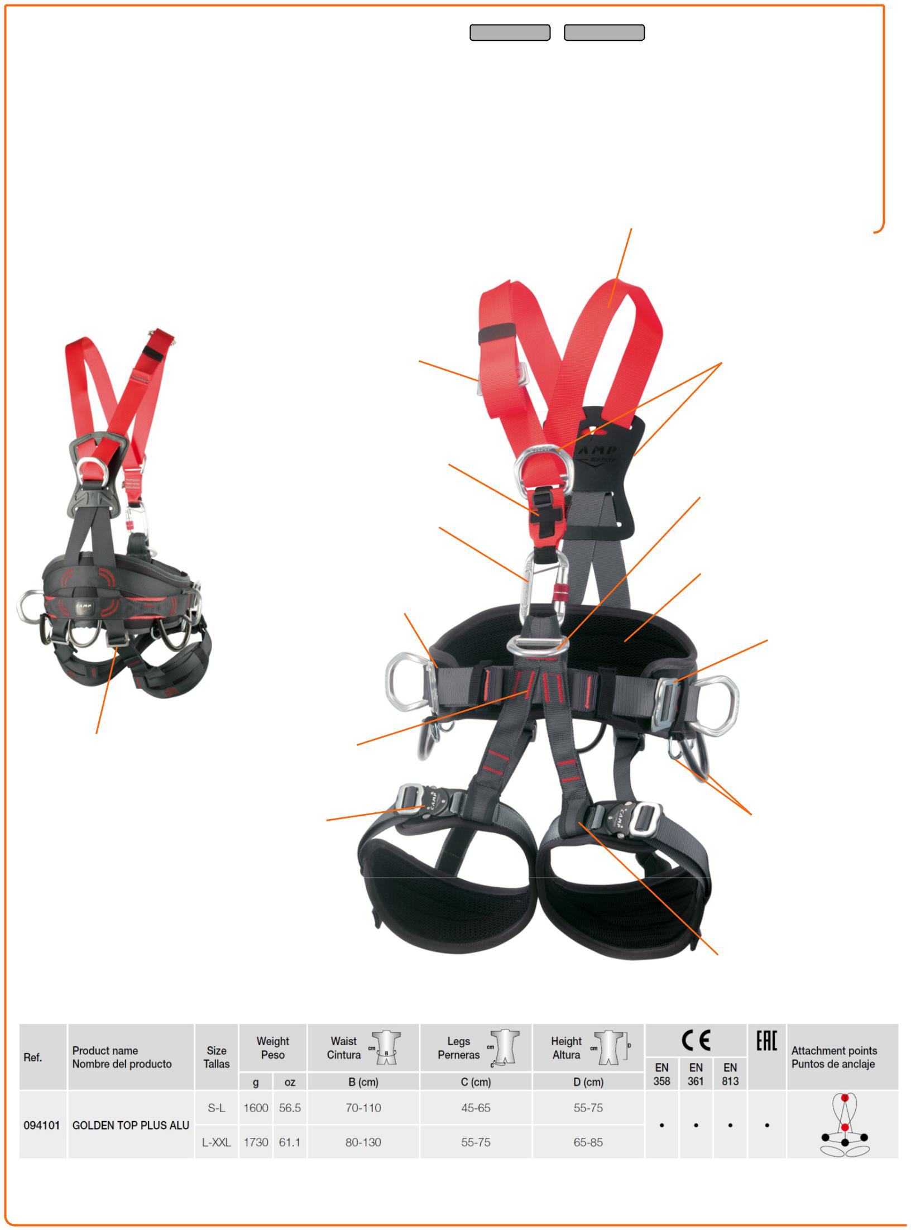

A versatile and lightweight full body harness designed for | ROPE ACCESS
professionals who require great freedom of movement during
ground operations without losing comfort during suspension.
Patented ventral attachment features two loops: the upper
loop is for attaching a chest harness and chest ascender and
the lower loop holds the ventral D-ring for attaching lanyards
and rope tools.
Lightweight Speedy Alu automatic buckles on the leg loops.
5 aluminum alloy attachment points: 1 sternal and 1 dorsal for
fall arrest, 1 ventral for suspension and 2 side for positioning
and restraint.
2 sizes.
2017 UPDATE: new keeper strap for securing a chest
ascender in a streamlined way.

Aluminium buckles

for chest adjustment.

Detachable

New chest ascender

fastening system

Aluminium connector

Strength: 22 kN

CE label

including batch and

serial number

Back webbing | High strength
adjustable | polyamide stitching
in length
 | Speedy Alu
 | automatic buckles

TOWERS/INDUSTRY
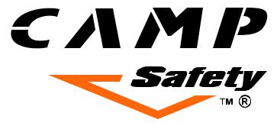

High strength polyester

webbing 44 mm

New forged aluminium

alloy fall arrest rings

Ventral attachment

point for suspension

3D mesh

padding

Aluminium buckles for belt adjustment. Detachable

 New forged

aluminium alloy

positioning ring

Gear-loops

Reinforced

webbings

TECHNICAL SHEET

01.02.17

